University of Plymouth

School of Engineering, Computing, and Mathematics

COMP3000

Final Year Computing Project 2020/2021

Back To Work

Evan Ward

10616392

BSc (Hons) Computer Science

# Introduction

## Background & Existing Solutions

### 1.1.1 Background

This project is designed to support households who struggle to keep their houses clean and tidy on a day-to-day basis and want to be a bit more organised around the home. This can apply to families or student/shared homes. As any person knows, doing chores is not fun and can be a daunting task at times. Children especially find it difficult to complete chores because they may feel it is a waste of their time which could be spent doing more exciting things that interest them. The same can be applied to some adults, however most adults see the importance of doing chores and just get on with it. From personal experience growing up with my siblings, chores were one thing we always disliked, and to this day they can still be tedious. However, as we grew into adults, we soon realised how important they were in teaching us life skills such as cooking, laundry organisation, responsibility and self-reliance.

Some families may also struggle to stay organised with assigning tasks. Methods such as displaying paper-based or whiteboard charts in the kitchen may not always work due to it being too tedious to physically write up a plan for the week or because they are easily destroyed. This was always an issue in my home. In an increasingly digital world, outdated methods of organising chores through paper-based and whiteboard charts have become obsolete. Every family nowadays has some access to the internet through various devices such as mobile phones, tablets or PCs. This project aims to take advantage of this by keeping families organised and digitally connected through a single website accessible through any device with an internet browser.

### 1.1.2 Existing Solutions

There are numerous mobile applications that offer some form of chore rosters that can be downloaded and installed from app stores. Each have similar features, such as the ability to assign chores to members of a group or offer rewards as an incentive for completing chores. However, these applications are restricted to mobile phones only, there are very few websites available on the internet that offer this kind of service. This project aims to fill that gap by offering a unique website that functions like mobile versions but with additional features and free of charge. By creating a full-stack website instead of a mobile application, this service can be accessed at any time through any device with an internet browser, making it portable and easy to use.

## Aims, Objectives and Deliverables

### Project Aims

The aim of this project is to produce a fully functioning full-stack website that offers the ability for users to add members to a household group where they can then assign chores to each member to complete within a given time.

This project is mainly aimed at families who struggle to organise and complete chores around the house. This project is also targeted at shared student homes who wish to have some form of chore roster to split chores amongst housemates.

Users will be rewarded with points for completing chores and can be redeemed for rewards of their choice when enough points have accumulated. If chores are not completed on time, points will be deducted from the user.

Users will also be able to set up a calendar that will be synced with the group. On this calendar, users can plan their week ahead by creating new events on the calendar. Users will also be able to view when their assigned chores need to be completed by on this calendar.

### Project Objectives

The following project objectives were established at the beginning of the project:

* Design a full stack interactive website that is user-friendly using storyboards.
* Set out the structure of a relational database for storing user data using entity relationship diagrams.
* Use HTML and CSS to implement the designed website.
* Setup a relational database using MySQL.
* Implement the functionality of the website using PHP as the server-side language and JavaScript as the client-side language.
* Deploy the website and database to Amazon Web Services for hosting.

### 1.2.3 Project Deliverables

The final deliverables of the project will consist of a fully functioning full-stack website and a project report outlining the process of designing, implementing and deploying of this project.

# Methods of Approach

## Project Structure

The structure of this project can be broken down into three parts:

* Planning
* Development
* Analysis

The planning phase at the start of the project was used to identify the problem and outline how a solution to this problem would be approached. By doing this I was able to select an appropriate project management approach that would be used to structure the development of the solution and which technologies would be used to develop the solution. This provided a clear guide as to how the solution would be designed and implemented in the development phase.

The development phase was the execution of the planned approach to the problem identified in the planning phase. The first step of this phase was to design the solution using storyboards, entity relationship diagrams and UML diagrams. The second step was to implement the designed solution. The third step was to test the implemented solution through usability studies to get valuable feedback that would be used to perfect the solution.

The analysis phase is the last phase. This phase would evaluate the project as a whole in the form of this written report.

## Agile Project Management

Agile project management was chosen as the approach to take for structuring this project. Agile project management is an iterative approach to software development where work is delivered in small increments throughout the development process instead of one big launch. Requirements, plans, and results are evaluated continuously so teams have a natural mechanism for responding to change quickly (Atlassian, 2021).

For this project, scrum was chosen as the agile methodology to be followed. The scrum methodology splits a project’s development into three parts:

* The Product Backlog
* The Sprint Backlog
* Increments

The product backlog outlines the master list of work that needs to be done. This is a dynamic list of features, requirements, enhancements, and fixes that acts as the input for sprints (Atlassian, 2021). For this project, my product backlog was outlined using Microsoft Planner.

The sprint backlog is the list of items, user stories, or bug fixes, selected by the development team for implementation in the current sprint cycle (Atlassian, 2021). Scrum breaks the development of a product into short sprints that last 2-4 weeks. Each sprint implements a select number of features chosen at the beginning of each sprint.

Increments are the usable end-product of a sprint (Atlassian, 2021). At the end of each sprint, a review is carried out that goes over what has been completed during the current sprint, any bugs that have been identified and need fixing, and planning for the next sprint cycle.

This methodology has allowed me to break my project into five sprints to work on over a period of four weeks each. At the end of each sprint, a review is carried out and I plan how I will implement the next sprint in line. This has allowed me to easily know what stage the development of the solution is in and has provided a clear guide as to how to go about developing it.

## Risk Assessment

At the start of the project during the planning phase, a risk assessment was carried out to identify any risks that may affect the project and how to overcome them.

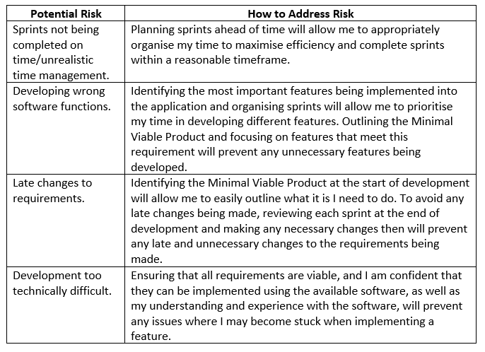

Figure 1 Risk Assessment

## Minimum Viable Product, Optional Requirements & Final Solution Limitations

### Minimum Viable Product

The following requirements are the minimum requirements of the solution and are considered to be the Minimal Viable Product:

* Allow users to create groups to add members of their family/household.
* Allow users to create new chores to be completed around the house.
* Allow users to assign chores to a member of their group to complete.
* Allow users to plan ahead by creating a new event on a calendar synced between the group.
* Allow users to view their assigned chores in a table and on the calendar.
* Allow users to earn reward points when completing a chore or deduct rewards when failing to complete a chore.

### Optional Requirements

The following requirements are considered to be optional and are only to be attempted if time permits it:

* Allow group members to message each other in a group chat.
* Allow group members to private message others within the same household group and outside their household group.
* Allow users to receive notification reminders for completing chores.

### Final Solution Limitations

The following is considered to be the limitations of the final solution:

* The final solution will be a website and so is only accessible through an internet web browser.

## 2.4 Tools & Technologies

### 2.4.1 HTML, CSS & PHP

PHP was used as the main backend language as well as HTML and CSS for the website design. I used PHP as the main server language because it can easily be embedded in HTML (PHP, 2021). I also chose to use PHP because I have a lot more experience using PHP than I do with any other backend language such as NodeJS.

### 2.4.2 JavaScript

JavaScript was used as the main frontend language. JavaScript is a scripting language that enables you to create dynamically updating content, control multimedia, animate images, and pretty much everything else (MDN Web Docs, 2021). I chose to use JavaScript because it is widely accepted by most web browsers and because I have a lot of experience using the language.

### MySQL

A MySQL server was used for storing user data instead of an alternative database such as MongoDB because MySQL allows for relational databases. This allowed me to easily implement the entity relationship diagrams I designed for each table into the database. MySQL is also an industry standard language that is widely accepted. I also decided to use MySQL because I have more experience using MySQL than I do MongoDB.

### 2.4.4 WAMP & Apache

Windows, Apache, MySQL and PHP (WAMP) are used for hosting websites that are in development. WAMP is a stack and so when installed on a windows desktop, Apache, MySQL and PHP come with it as a bundle (Hostinger Tutorials, 2021). WAMP was used locally on my PC for developing the website and Apache was used on a remote server for hosting.

### Amazon Web Services

Amazon Web Services (AWS) was used for the hosting of the website and MySQL database. AWS has a variety of services that users can use to build and deploy applications. I used AWS to create an EC2 Windows Server 2019 instance running Apache for hosting the website. I also used AWS to create and host a RDS MySQL database server for storing user data securely.